Assignment No. 10
- TITLE : Implement a program for maintaining a database of student records using Files. Students have Student_id,name, Roll_no, Class, marks and address. Display the data for a few students. 1. Create Database 2. Display Database 3. Delete Records 4. Update Record 5. Search Record
- CODE:
#include<iostream>
#include<fstream>
using namespace std;

class Student {
public:
string name;
int roll;
int marks;
string division;
void displayInfo() {
cout<<name<<" "<<roll<<" "<<marks<<" "<<division<<endl;
}
void getInfo() {
cout << "Enter Name: ";
cin >> name;
cout << "Enter Roll Number: ";
cin >> roll;
cout << "Enter Marks: ";
cin >> marks;
cout << "Enter Division: ";
cin >> division;
}
void insertNewRecord(){
fstream fout("students.txt", ios::app);
fout << name << " " << roll << " " << marks << " " << division << endl;
fout.close();
}
void displayAllRecords(){
fstream fin("students.txt", ios::in);
string n, d;
int r, m;
cout << "\n--- Student Records ---" << endl;
while(fin >> n >> r >> m >> d){
cout << n << " " << r << " " << m << " " << d << endl;
}
fin.close();
}
void searchRecord(int sroll){
cout << "\nSearching for Roll Number: " << sroll << endl;
fstream fin("students.txt", ios::in);
string n, d;
int r, m;
while(fin >> n >> r >> m >> d){
if(r==sroll){
cout << "Record Found: " << n << " " << r << " " << m << " " << d << endl;
fin.close();
return;
}else{
cout << "Record Not Found" << endl;
}
}
}
void deleteRecord(int sroll){
fstream fin("students.txt", ios::in);
fstream fout("temp.txt", ios::out);
string n, d;
int r, m;
while(fin >> n >> r >> m >> d){
if(r!=sroll){
fout << n << " " << r << " " << m << " " << d << endl;
}
}

fin.close();
fout.close();
remove("students.txt");
rename("temp.txt", "students.txt");
cout << "Record with Roll Number " << sroll << " deleted." << endl;
}
void updateRecord(int sroll){
fstream fin("students.txt", ios::in);
fstream fout("temp.txt", ios::out);
string n, d;
int r, m;
while(fin >> n >> r >> m >> d){
if(r==sroll){
cout << "Enter New Details for Roll Number " << sroll << ":\n";
getInfo();
fout << name << " " << roll << " " << marks << " " << division << endl;
}else{
fout << n << " " << r << " " << m << " " << d << endl;
}
}
fin.close();
fout.close();
remove("students.txt");
rename("temp.txt", "students.txt");
cout << "Record with Roll Number " << sroll << " updated." << endl;
}
};

int main() {
Student student;
int ch, rollNo;
while(true){
cout << "\n1. Insert New Record\n2. Display All Records\n3. Search Record\n4. Delete Record\n5. Update Record\n6. Exit\nEnter your choice: ";
cin >> ch;
if(ch==6) break;
switch(ch){
case 1:
student.getInfo();
student.insertNewRecord();
break;
case 2:
student.displayAllRecords();
break;
case 3:
cout << "Enter Roll Number to Search: ";
cin >> rollNo;
student.searchRecord(rollNo);
break;
case 4:
cout << "Enter Roll Number to Delete: ";
cin >> rollNo;
student.deleteRecord(rollNo);
break;
case 5:
cout << "Enter Roll Number to Update: ";
cin >> rollNo;
student.updateRecord(rollNo);
break;
default:
cout << "Invalid Choice!" << endl;
}
}
}

Output –
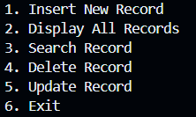
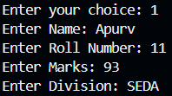
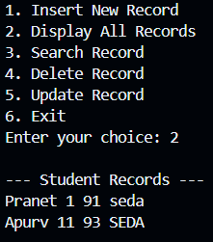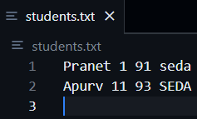

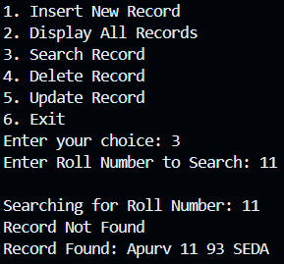
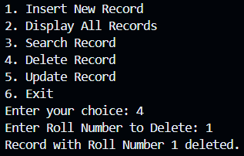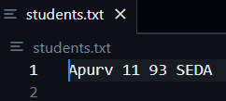
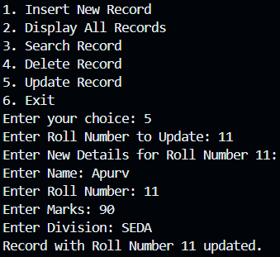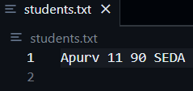

- Conclusion – In this assignment, we’ve implemented program on implementation Of handling student data using file handling operations and methods.

